Central Louisiana Infrastructure
Beltway Commission Meeting

March 22, 2012

Minutes

1. Call to Order
By Mayor Jacques Roy

2. Roll Call
Members Present:

Mayor Jacques Roy
Mayor Clarence Fields
Mayor Jonathan Dean
Mayor David Butler
Mayor Jack Dewitt
Oliver Overton
David Manuel
Jon Grafton
Reldon Owens
Arnold Murrell

Others Present

Dennis Woodward
Richard Billings
Brandon Buckner
Keith Sayer
Matt Johns
Vera Zhang

3. Approval of Minutes of December 21, 2011 Meeting
- Motion by Mayor David Butler
-2nd by Mayor Clarence Fields
Passed Unanimously

4. Discussion of Designee Selection
Suspend this item for later discussion.
- Motion by Mayor David Butler
-2nd by Jon Grafton
Passed Unanimously

5. Distribution and Completion of Oath of Office and Swearing-In of New Members
Mayor Jacques Roy led the swear-in. Members stood up and swore in new members.

6. Review and Selection of Official Seal
Mayor Roy led the discussion. Ten seal designs were shown to the board members. Mayor Roy said he did not like the design with the long acronym, because the acronym did not make itself clear what it stood for. Jon Grafton pointed out that the seal must be a strong statement for the Beltway Commission. Such a seal would be easy for people to identify on a highway sign in the future.
Jon also said that the modern design looked fine but might resemble some private firm logos. Mayor David Butler asked whether the faded and divided rotary pattern (option 2 below) had a special meaning. Mayor Roy said it meant movement and never ending effort. After discussion, the board decided to combine and modify the features of the two options shown as blow:

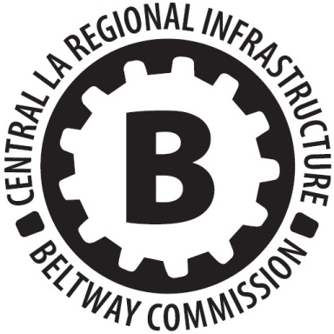
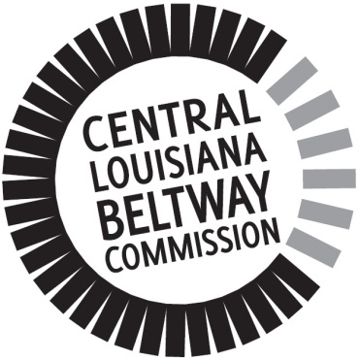
Option 1 Option 2

Option 1 was initially the primary choice of the board. Upon discussion, the board wanted to replace the rotary pattern in Option 1 with the radial pattern in Option 2; while keeping the bold B in the center of the Option 1. Rephrase the circumscribed words to be “Central Louisiana Beltway Commission”. The final seal design is shown as below:
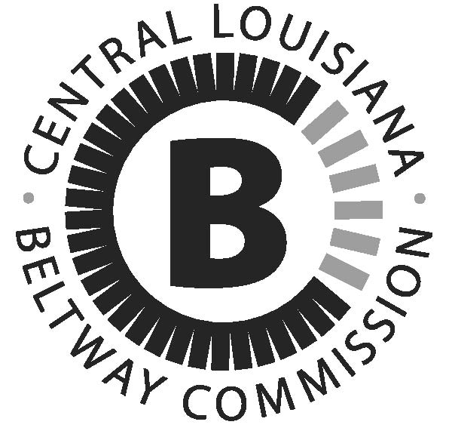
The board would direct the graphic designer to modify the seal and RAPC staff would email the board members the final design. (RAPC staff sent out the final design to the board members via email on March 27th, 2012.)
- Motion by Mayor David Butler to adopt the final design
-2nd by Mayor Jack Dewitt
Passed Unanimously

7. Review and Possible Adoption of By-Laws
Mayor Roy reminded the board that the by-laws were reviewed in the last beltway meeting.
- Motion by Oliver Overton to adopt the by-laws written by the MPO staff
-2nd by Jon Grafton
Passed Unanimously

8. Steering Committee Report
-Technical Advisory Committee Recommendation
Matt Johns reported that, per the discussion of the Steering Committee, the Beltway Technical Advisory Committee (Beltway TAC) was formed based on the MPO Technical Advisory Committee (MPO TAC). In addition, Cleco, Bell South, AT&T, and Meyer, Meyer, LaCroix & Hixson were added to the Beltway TAC. Mayor David Butler asked why Meyer Meyer was added to the TAC. Matt answered that Meyer Meyer was the major engineering firm in the region and had good experience. Jon Grafton asked whether Pan American was included. Matt said it was included because it was on the MPO TAC. Mayor Roy said that Pan American and Meyer Meyer both had rich experience in large-scaled infrastructure project in the region. Their engineers would provide valuable opinions for the beltway project. Jon Grafton mentioned that AT&T and Cleco may or may not provide lots of input to the project according to his previous experience. Mayor Jonathan Dean asked whether AT&T and Bell South was the same thing now. Jon answered yes. Matt removed Bell South from the representation. Jon Grafton as the chair of the Steering Committee confirmed Matt’s report. Mayor Roy asked the Steering Committee members to identify themselves. The Steering Committee members are: Jon Grafton, Reldon Owens, Mayor Jonathan Dean, Dr. David Manuel, and Keith Sayer.
- Motion by Mayor David Butler to adopt the Steering Committee’s report
-2nd by Mayor Jack Dewitt
Passed Unanimously

-Beltway Study Proposal-will need board approval before submission
Matt Johns reported that the Beltway Study Proposal was written in accordance with FHWA’s guidelines and the Beltway Commission’s instructions. The proposal aimed to complete the “Phase I” study – the feasibility study of the project. MPO Policy Committee had approved to allocate $250,000 STP fund per year, four years in a roll, to the Beltway Study.
Mayor David Butler pointed out that in the proposal there was a jurisdiction called “Southern Rapides”. Mayor Roy directed the MPO staff to rephrase the description into “Rapides Parish and Southern Grant”.
Matt said the first page of the proposal was the cover letter. The second part of the proposal was a purpose statement. Starting from the third part, the proposal specified the detailed tasks that needed to be completed. The study would cover four fiscal years: 13, 14, 15, and 16.
- Motion by Oliver Overton to adopt the Beltway Study Proposal
-2nd by Mayor Clarence Fields
Passed Unanimously

9. Other Business
Mayor Roy said that a bank account was needed to deposit funds and operate tasks. The first bill was the $900 for the seal design. Mayor Roy asked Matt Johns what bank RAPC used. Matt said Chase Bank. Mayor Roy asked how RAPC wanted to operate the financial activities, including managing the bank account and reimbursement. Jon Grafton recommended that RAPC draft a Scope of Service proposal to clarify the administrative services that RAPC would provide to the Beltway Commission. This proposal should be submitted to the next beltway meeting for adoption.
- Motion by Jon Grafton to direct the MPO staff to draft a Scope of Service document
-2nd by David Manuel
Passed Unanimously

10. Add the Suspended Item “Discussion of Designee Selection” Back to the Agenda
- Motion by Mayor David Butler
-2nd by Mayor Jack Dewitt
Passed Unanimously
Mayor Roy proposed RAPC to be the administrative designee for the Beltway Commission.
- Motion by Mayor David Butler
-2nd by Mayor Jack Dewitt
Passed Unanimously

11. Adjournment
- Motion by Mayor Clarence Fields
-2nd by Mayor Jack Dewitt
Passed Unanimously

Respectively submitted by,

Vera Zhang

